Csn-261

RAPAKA VINEETH KUMAR

18114063-CSE

ASSIGNMENT 4

Problem Statement 1: Create a dictionary using Trie data structure (without using STL) having words and their meanings. You need to read the words and their respective meanings from a CSV file (uploaded in Piazza, named as TrieInput.csv), where 1st column is for words and 2nd column shows its meaning. Given a word you have to print its meaning. If no such word is found in the dictionary, then print “Invalid word”. Create a GUI using Qt library to accept a word in a text box and display the meaning in an another box, as shown in the Figure 1. Also, create an installer of your program for Windows OS. You can use the software like InstallShield or WIX or NSIS to do so

Algorithm:

1)Trie insertion algorithm is used

2)some file handling algorithm is used

3)GUI is used for creating dialogue boxes

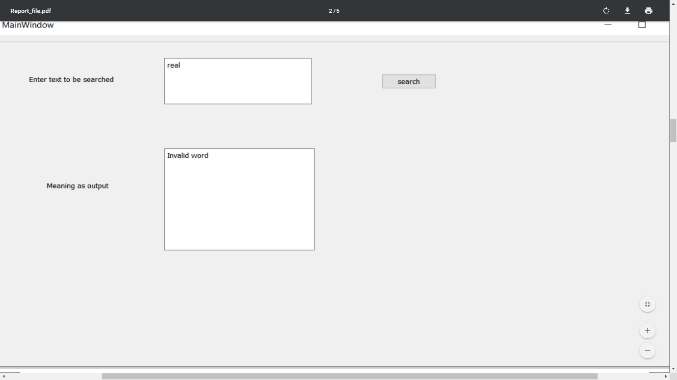

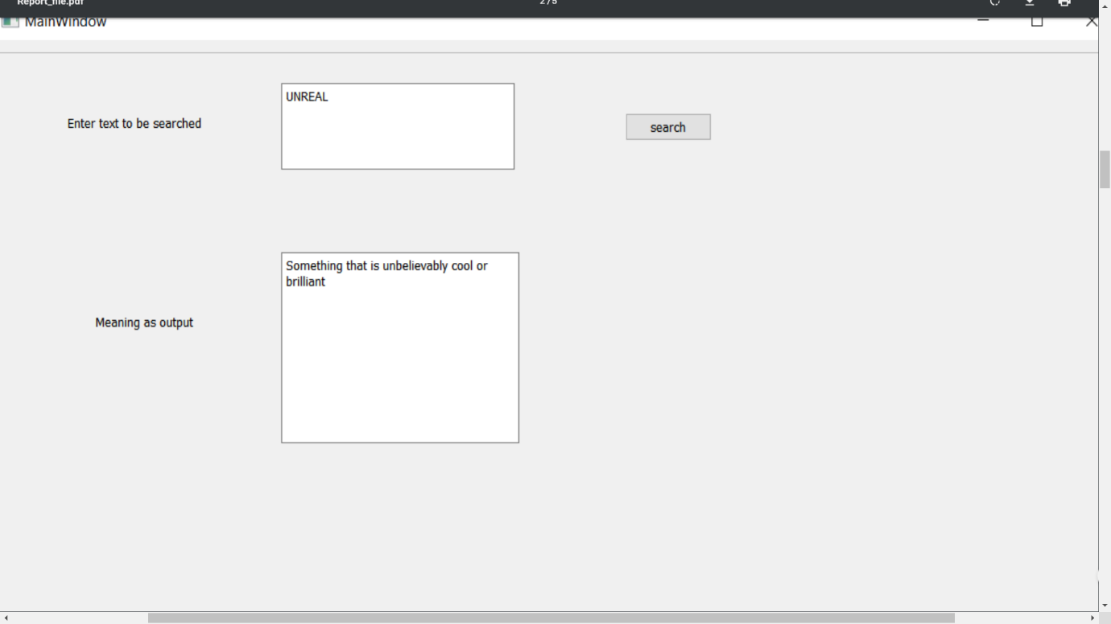

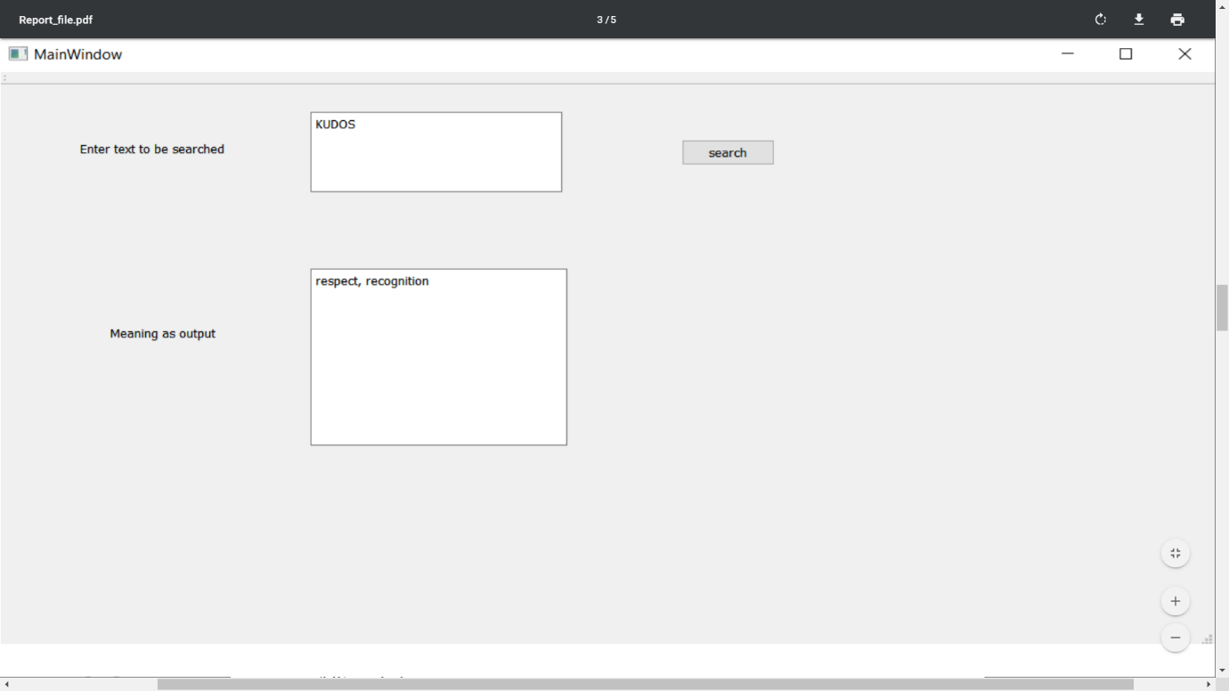

Problem statement 2: Implement N Queens problem to show all the possible combinations in N x N binary matrix and to display the total number of such combinations at the end, where 1 represent the position of N queens in the N x N matrix and remaining cells are represented by 0. A sample output for N=4 is shown below.

Algorithm:

1)Simple looping

2)creation of 2d array

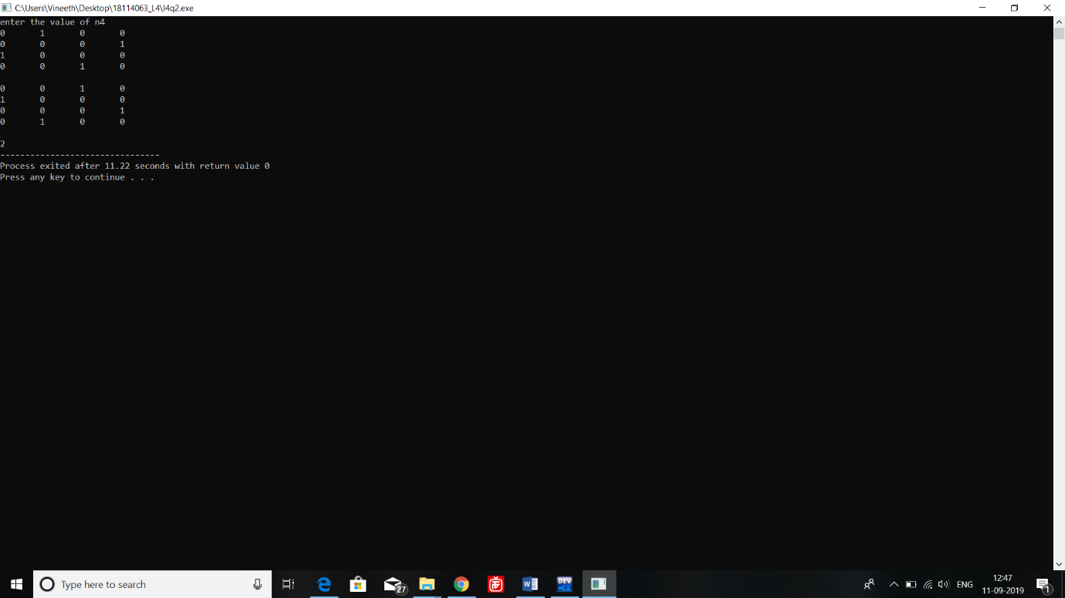

Problem statement 3: Given an integer array having N number of elements, write a C++ program using hash map (using STL) to find the length of the largest subarray from the given input array, where the summation of the elements of the subarray is equal to n. In the output, if any solution exists then print the starting and ending index (with respect to given input array) of the largest subarray and also print its length. Otherwise, print “Not Found”, as described in the following output Algorithm:

1)Store the sumform particular index to another index into the hashmap

2)Then they are used whenever required

